EMG EDA

Here I wanted to explore the visualization of the data more to see the layout for channel units in the Amplitude Probability Density Functions.

* Box Plot Cervical PS LT:
  + 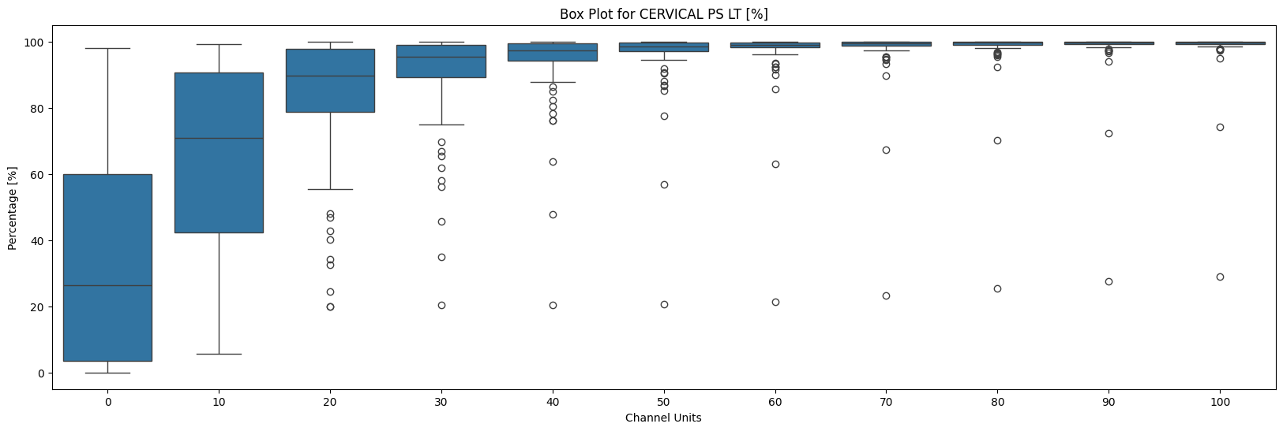
* Box Plot Cervical PS RT:
  + 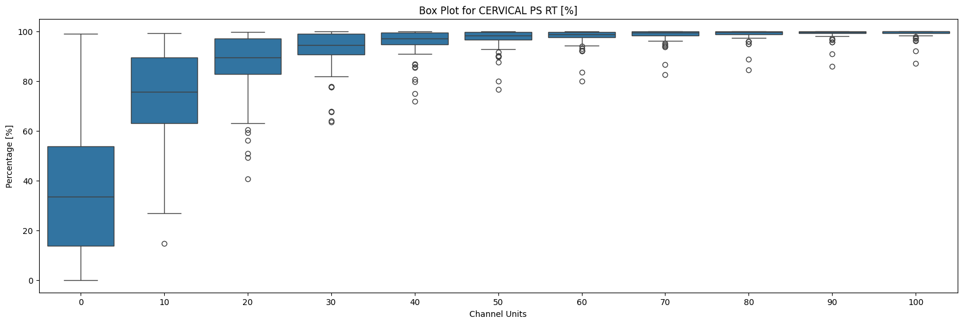
* Box Plot Upper Trap LT:
  + 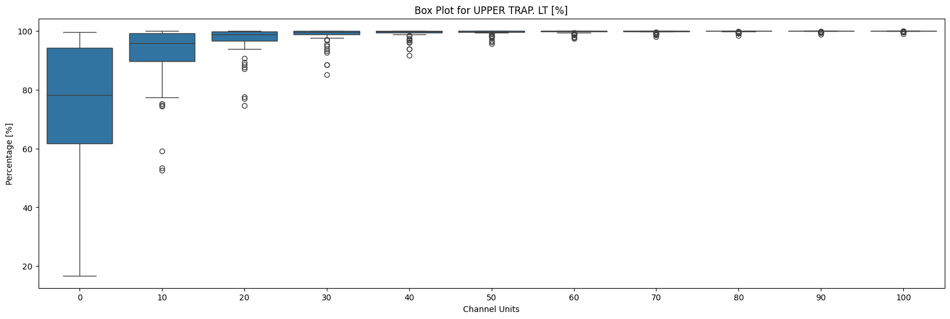
* Box Plot Upper Trap RT:
  + 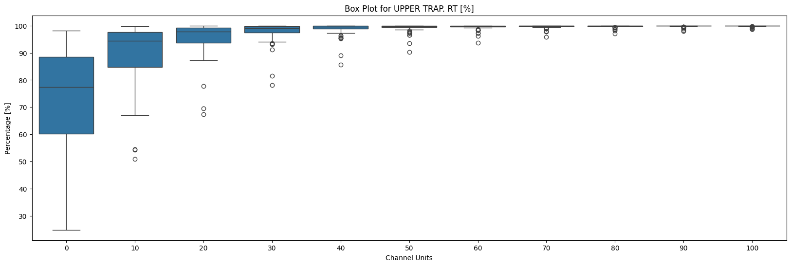
* Box Plot Lumbar LT:
  + 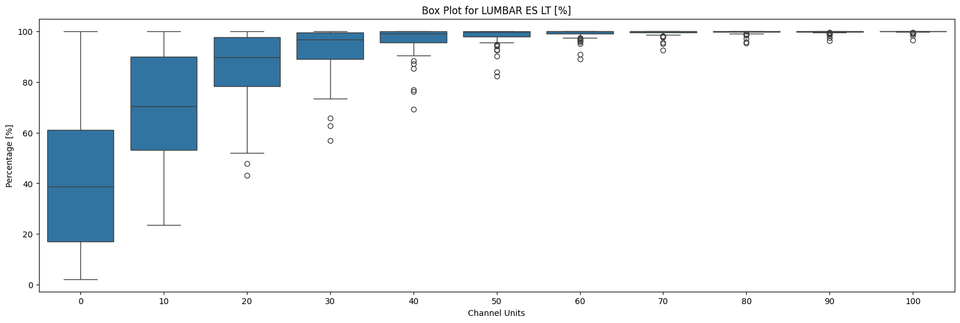
* Box Plot Lumbar RT:
  + 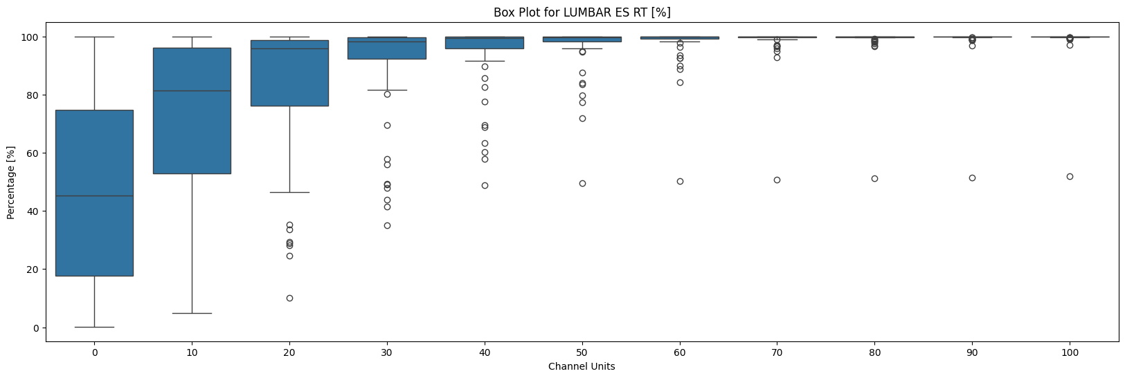
* Box Plot Middle Trap LT:
  + 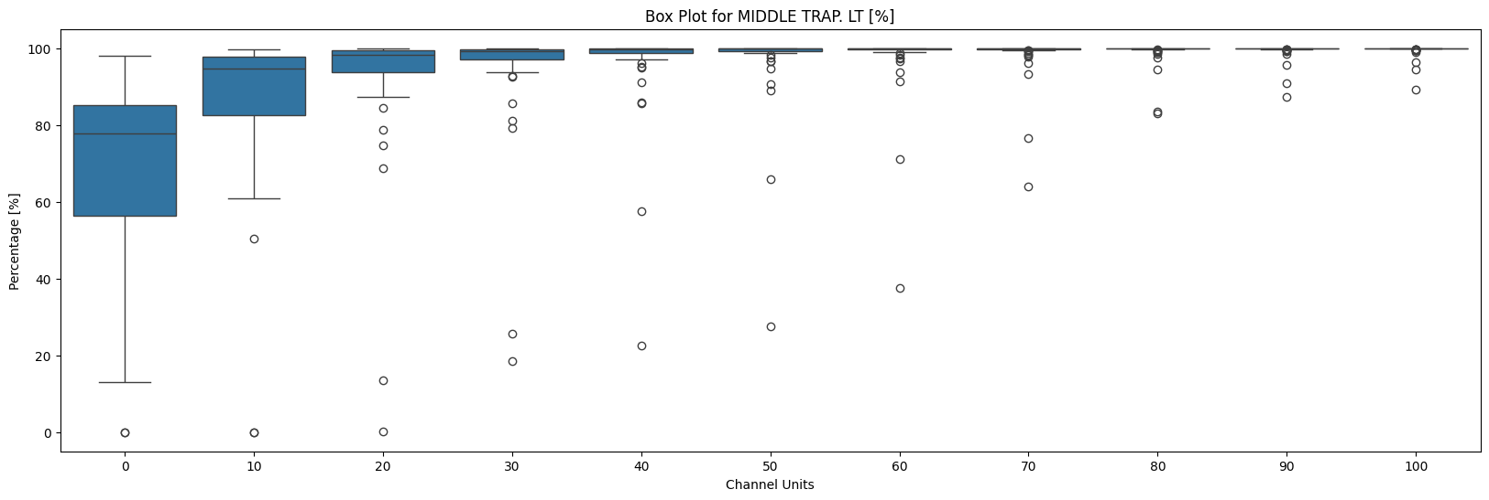
* Box Plot Middle Trap RT:
  + 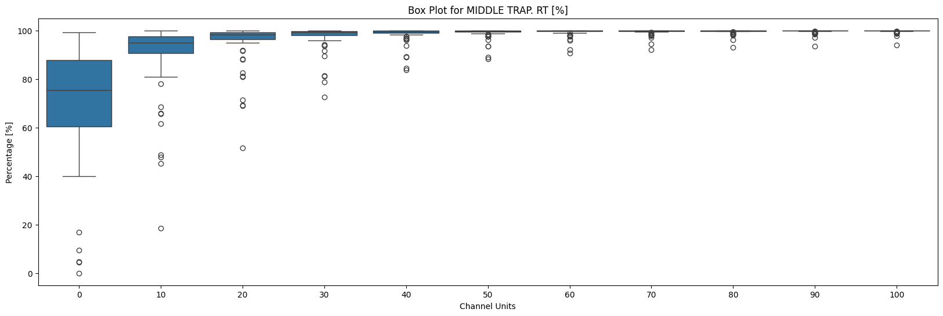
* I referenced time_point as the Channel units of 00 = 0 and 01 =10 respectively:
  + 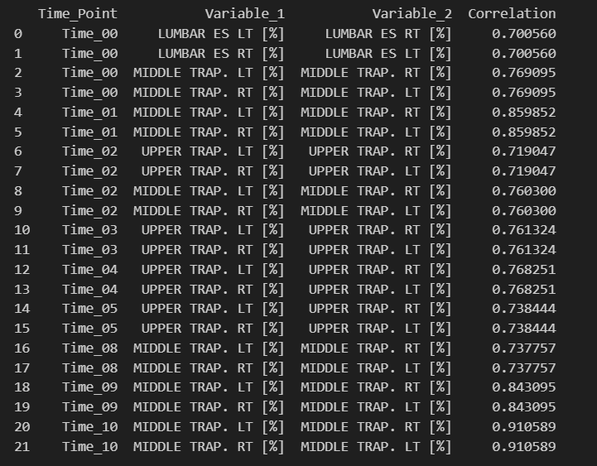
* Muscle Activity for each Channel Unit Average of all cases:
  + 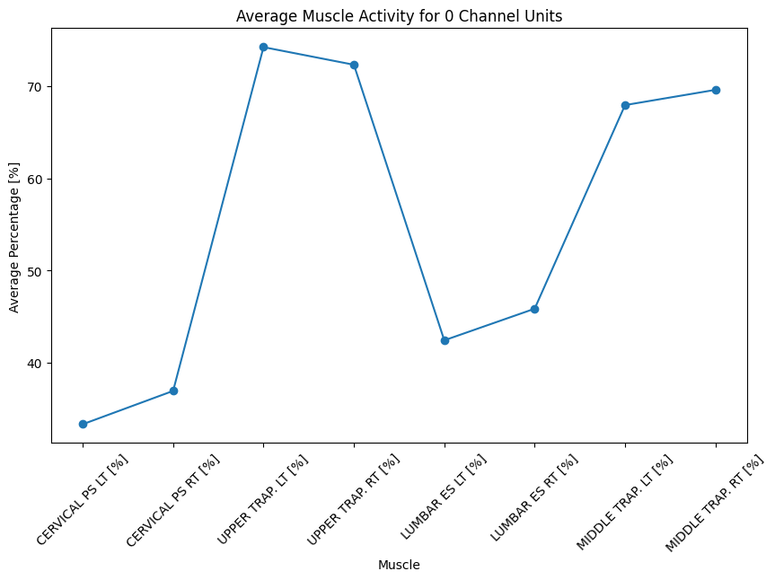
  + 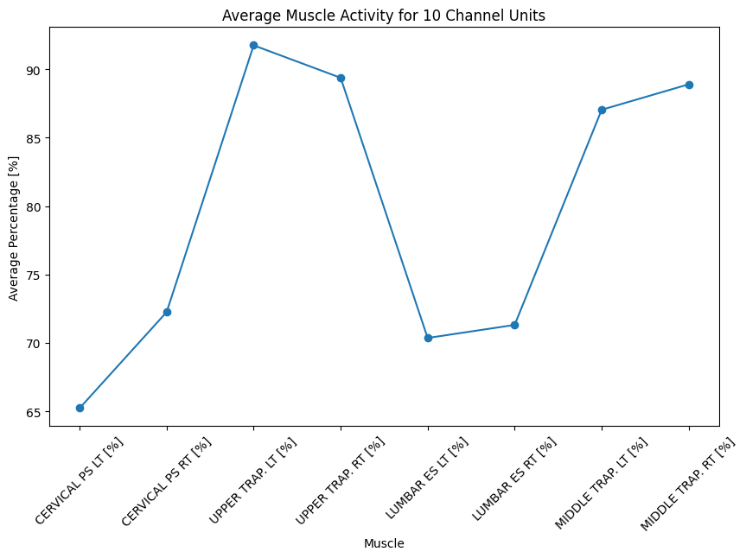
  + 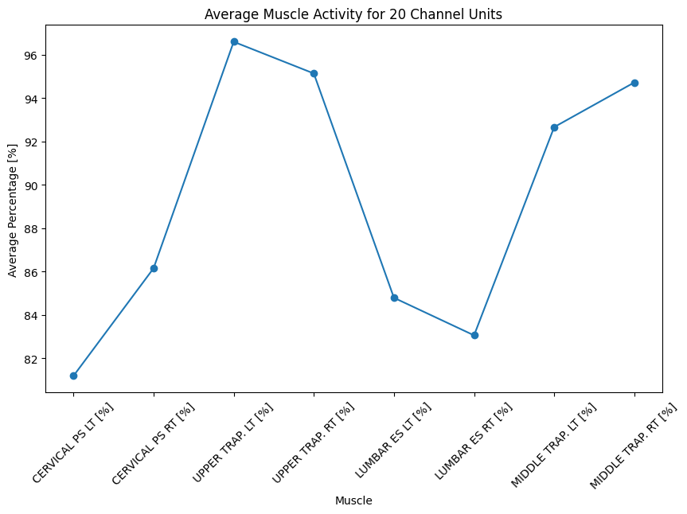
  + 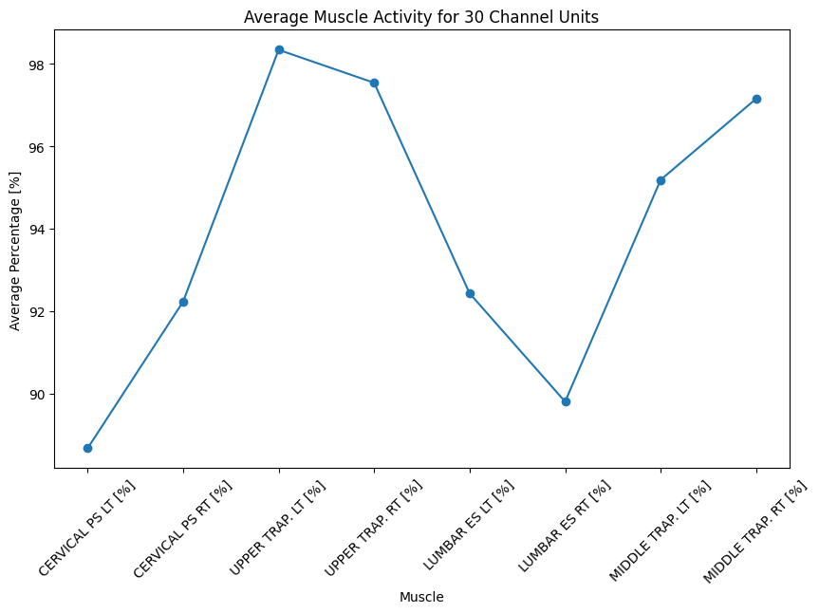
  + 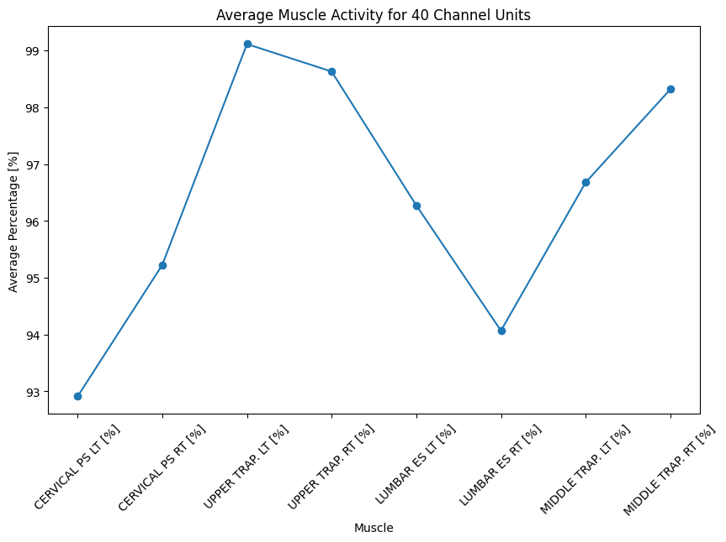
  + 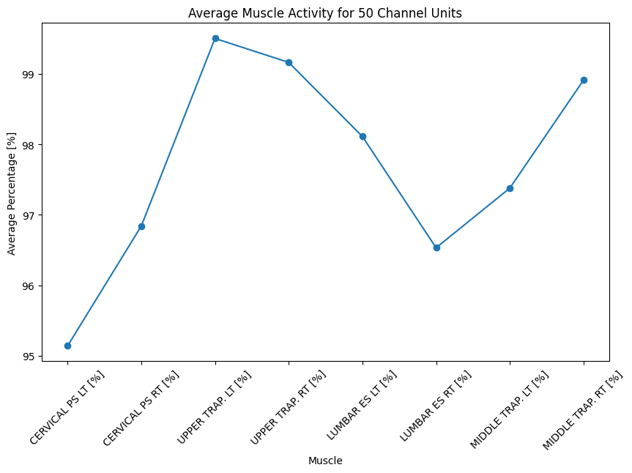
  + 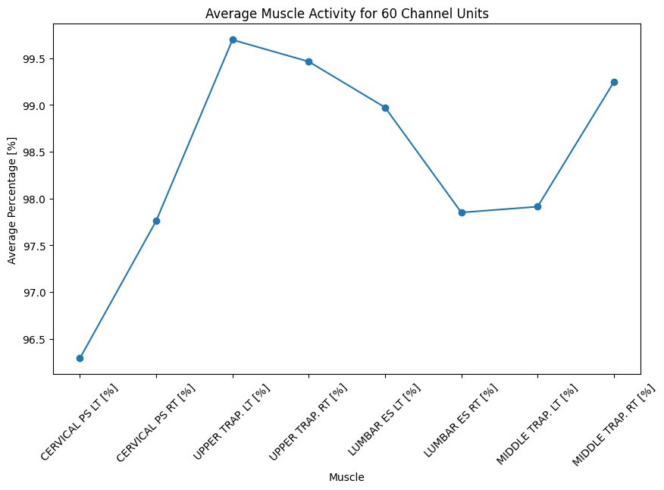
  + 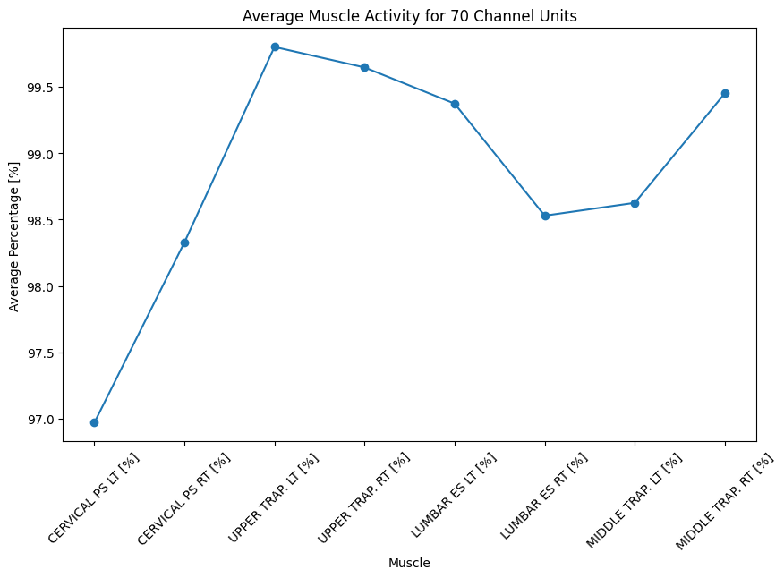
  + 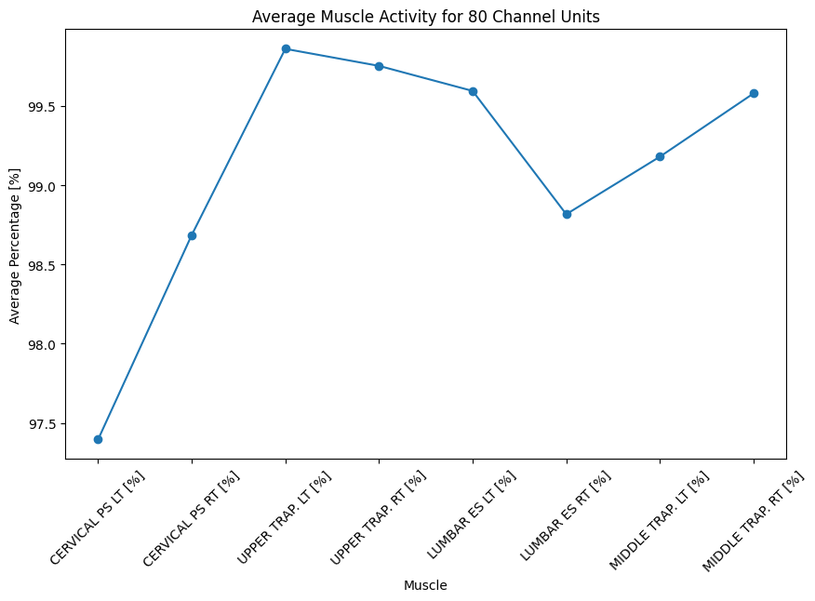
  + 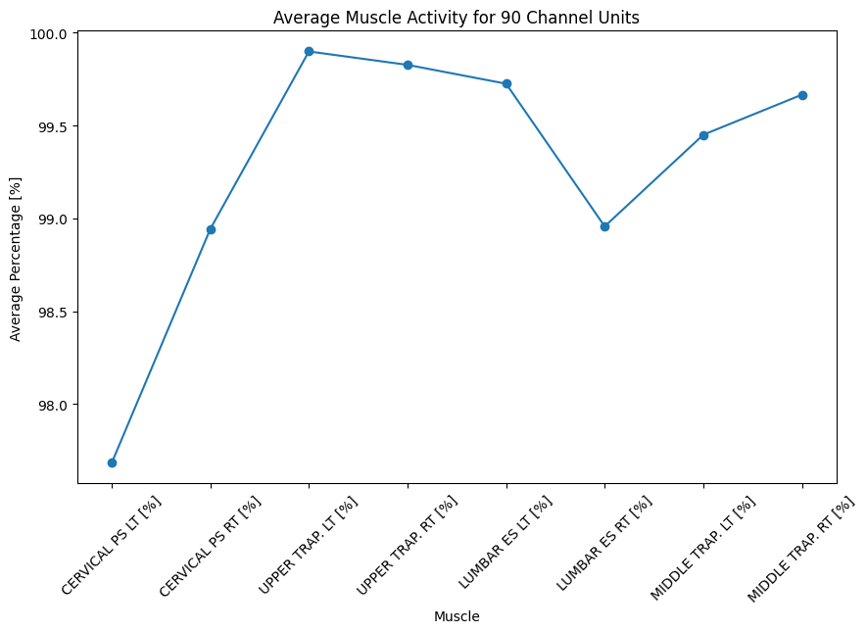
  + 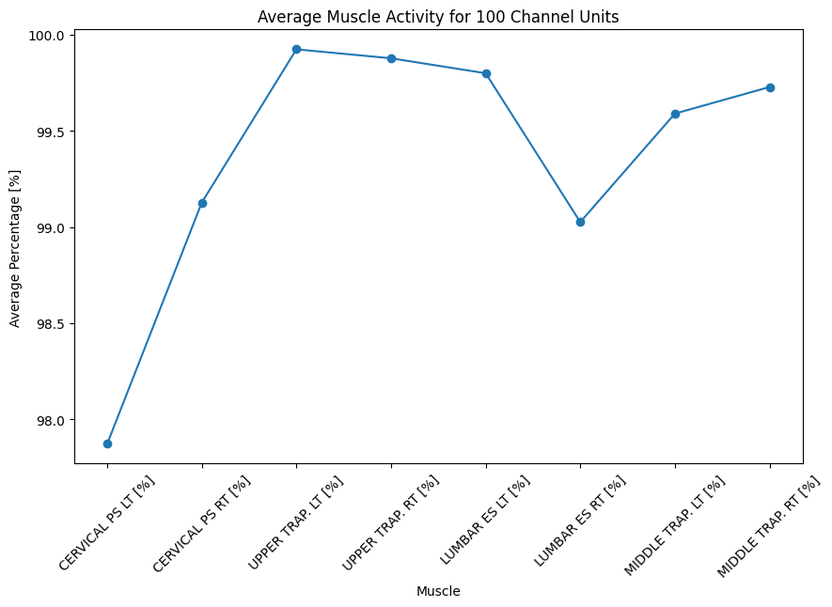
* Channel Units 0 Descriptive Statistics
  + 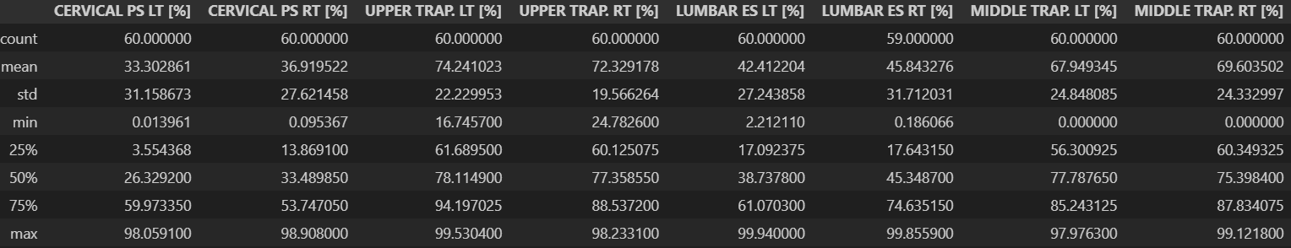
* Channel Units 10 Descriptive Statistics
  + 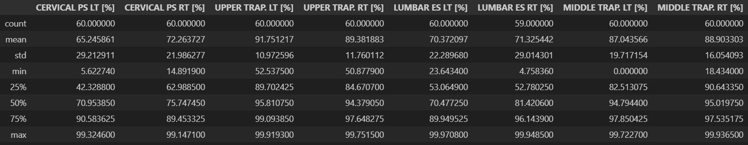
* Channel Units 20 Descriptive Statistics
  + 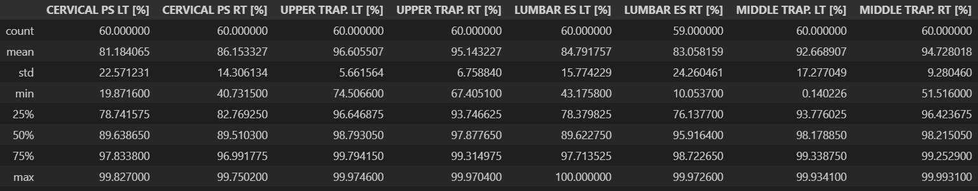
* Channel Units 30 Descriptive Statistics
  + 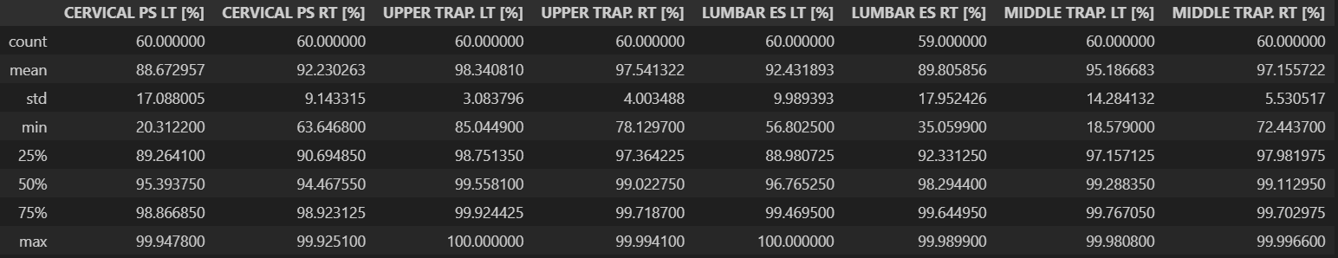
* Channel Units 40 Descriptive Statistics
  + 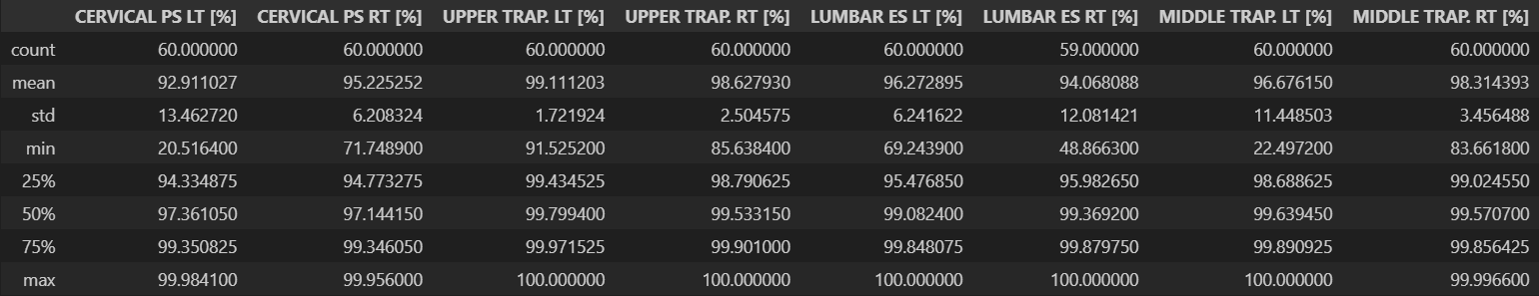
* Channel Units 50 Descriptive Statistics
  + 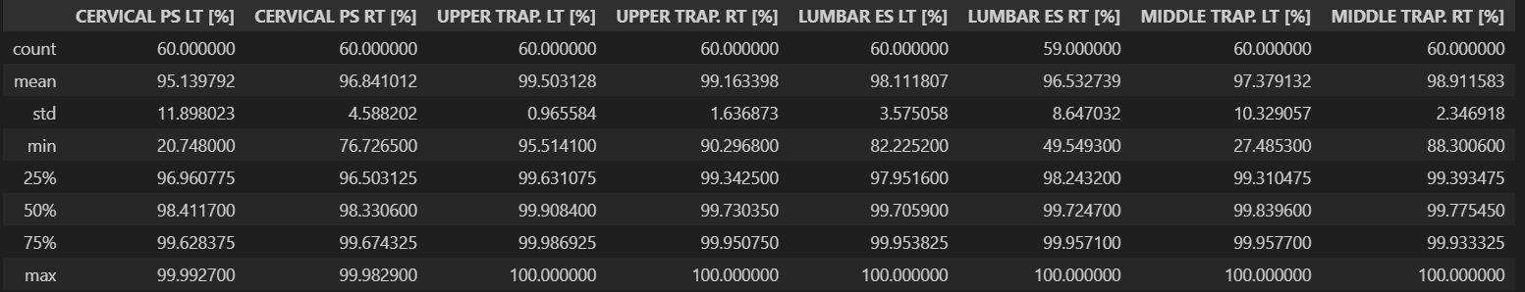
* Channel Units 60 Descriptive Statistics
  + 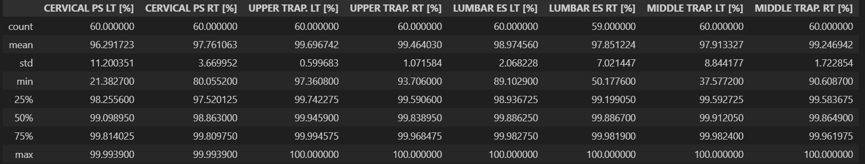
* Channel Units 70 Descriptive Statistics
  + 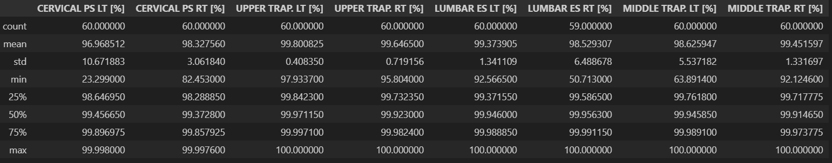
* Channel Units 80 Descriptive Statistics
  + 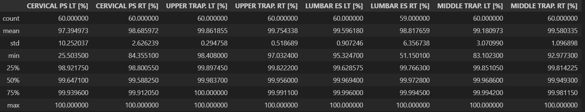
* Channel Units 90 Descriptive Statistics
  + 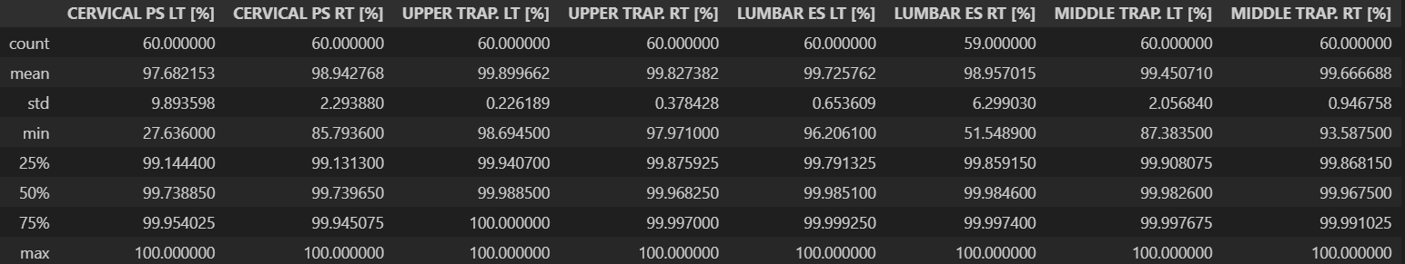
* Channel Units 100 Descriptive Statistics
  + 